
UNIVERSITI TEKNOLOGI MARA (UiTM)
CAWANGAN KELANTAN KAMPUS MACHANG
BACHELOR OF INFORMATION TECHNOLOGY (HONS.)

FINAL YEAR PROJECT PROPOSAL
PROJECT FORMULATION
(CSP600)

TITLE :
TutorMeQuran: A Web Application for Booking Quran Tutors in Malaysia

CLASS:
CDCS2405B

PREPARED BY:
NO. | NAME | STUDENT ID
1. | TENGKU AHMAD DANIAL BIN TENGKU NOOR ASHRAF | 2025197383

DATE OF SUBMISSION: 13/7/2026

PREPARED FOR:
PROFESOR MADYA DR. NOORIHAN BINTI ABDUL RAHMAN @ ABDUL RASHID
SESSION II MARCH - AUGUST 2026

SUPERVISOR:
PUAN ASIAH BINTI MAT
TABLE OF CONTENTS

CHAPTER 1 1
INTRODUCTION 1
1.1 BACKGROUND OF STUDY 1
1.2 PROBLEM STATEMENTS 2
1.3 RESEARCH QUESTION 3
1.4 RESEARCH OBJECTIVES 3
1.5 PROJECT SCOPE 4
1.6 SIGNIFICANCE OF THE STUDY 4
1.7 PROJECT LIMITATION 5
1.8 CHAPTER SUMMARY 6
CHAPTER 2 7
LITERATURE REVIEW 7
2.1 INTRODUCTION 7
2.2 DOMAIN AREA: Quranic Education in Malaysia 8
2.2.1 An overview 8
2.2.2 Related Issues/problems 10
2.2.3 Current method/technique & issues (Comparison Table) 12
2.3 SUBJECT MATTER: Web-Based Appointment Scheduling Systems 14
2.3.1 An overview 14
2.3.2 Methods/Technique/Algorithm in this area 15
2.3.3 Related current studies & Issues (Comparison Table) 17
2.4 SPECIFIC SELECTED METHODOLOGY: Agile Scrum and System Usability Scale (SUS) 19
2.4.1 An overview of Agile Scrum and SUS 19
2.4.2 Fundamental/Basic Process flow of the Technique/Method 20
2.4.3 Advantages/Benefits 21
2.4.4 Related Current studies & Issues (Comparison Table) 23
2.5 SIMILAR STUDIES/APPLICATIONS 25
2.5.1 TeacherOn 25
2.5.2 Qutor.com 26
2.5.3 Preply 27
2.5.4 Superprof Malaysia 28
2.5.5 MyTutor.My 29
2.5.6 Discussion on the comparison of Similar Studies/Application 29
2.6 CHAPTER SUMMARY 31
CHAPTER 3 32
METHODOLOGY 32
3.1 OVERVIEW OF AGILE SCRUM 32
3.1.1 Justification for Agile Scrum 33
3.1.2 Overview of Agile Scrum Phases 34
3.2 Phase 1: Product Backlog 35
3.2.1 Initial Requirement Gathering 36
3.2.1.1 Literature Review Analysis 36
3.2.1.2 User Survey 36
3.2.2 System Scope 37
3.2.3 User Roles 37
3.3 Phase 2: Sprint Backlog 38
3.3.1 Use Case Diagram for TutorMeQuran 39
3.3.2 Flow Overview of the System 40
3.3.3 System Requirement Specification (SRS) 41
3.3.3.1 Functional Requirements 41
3.3.3.2 Non-Functional Requirements 42
3.3.3.3 Hardware 42
3.3.3.4 Software 43
3.4 Phase 3: Sprint Week Execution (Iterative Design & Development) 44
3.4.1 User Interface Wireframe 44
3.4.2 Entity-Relationship Diagram for TutorMeQuran 45
3.5 Phase 4: Sprint Review, Retrospective and System Evaluation 47
3.5.1 System Usability Scale (SUS) Questionnaire 47
3.6 GANTT CHART 48
3.7 CHAPTER SUMMARY 49
REFERENCES 50

CHAPTER 1

INTRODUCTION

This chapter introduce the background of the study and highlight the main issue regarding Quranic education in Malaysia. It explain the problem faced by students when finding certified tutors using manual methods. Furthermore, this chapter propose the development of the TutorMeQuran web application as the main solution and list down the specific research objective to guide the whole project.

1.1 BACKGROUND OF STUDY

In Malaysia, learning to read the Quran and mastering Tajweed is a very important duty for all Muslims. It is considered as an individual obligation or fardlu 'ain. To learn the Quran properly, the most authentic method used since the old times is talaqqi musyafahah. This mean the student need to learn face-to-face and online directly with a qualified teacher to make sure their pronunciation is correct (Salleh et al., 2025). Even though digital technology is growing fast today, learning directly from a real human teacher is still the best way to avoid serious reading mistakes (Mohd Ghazali et al., 2025; Salleh et al., 2025).

However, as the modern lifestyle become busier, many youths and university students struggle to keep a consistent Quran reading routine. Because of this lack of practice, they slowly face a decline in their recitation skill and easily forget the basic rule of Tajweed (Faris et al., 2023). At the same time, technology has become more common in Quranic learning support in Malaysia, especially through online learning tools and digital platforms (Mohtar et al., 2022; Salleh et al., 2025). Therefore, this project focus on Malaysian users who already have basic knowledge in using smartphone, laptop, or computer to access a web-based system.

Even when the student have the motivation to learn, they face a big logistical gap. They struggle to find, verify, and schedule sessions with a qualified tutor near their place. Currently, they are forced to rely on traditional manual methods like asking friend, using WhatsApp, or searching unstructured social media to arrange a class (Safari et al., 2018). In this project, manual method means the booking process is not handled by a proper computerized system. This manual process is very unorganized and make it hard for students to check tutor availability, confirm tutor qualification, and avoid booking mistake (Natarajan et al., 2024; Saavedra et al., 2024). Therefore, a modern approach is needed to bridge this gap between the student and the Quran tutor.

1.2 PROBLEM STATEMENTS

Currently, many youths and university students in Malaysia have low Quran reading skill and lack basic understanding of Tajweed. A study by Faris et al. (2023) found that many public university students have weak Quran reading proficiency because they forget the correct articulation point of a letter. When they try to improve their reading, they face a big difficulty in finding qualified and certified Quran tutor near their location. Safari et al. (2018) state that it is a major challenge for students to find qualified tutors using unstructured manual methods. The current market lacks a structured platform, so people mostly use manual booking methods like WhatsApp to arrange class. Because they use manual text messaging, tutors find it hard to track appointments which lead to double-booking error and cancelled sessions (Saavedra et al., 2024).

Furthermore, pricing for independent Quran class is often unclear because it rely on "Hadiya" or voluntary donation. This make students confused about the expected cost for the lesson. Lastly, finding an authentic teacher is a serious issue. Al-khatib (2023) highlight that having a Quranic Ijazah is very important to prove a teacher's competency, but informal social media platform do not have any system to verify this. Because of this lack of verification, students might accidentally learn from unqualified individual which can worsen their reading mistakes (Che Noh et al., 2013). This situation show a clear need for a better system to manage tutor booking in Malaysia.

To solve all these problems, the proposed solution is to develop a web application named TutorMeQuran. This system will provide a centralized database platform for students to find and book Quran tutor in Malaysia efficiently. As the main feature, the system will have an automated scheduling using a real-time booking calendar. This will help students to view the tutor available slot and book class that match their own flexible schedule, which completely avoid double-booking error. Next, to make sure the education quality is safe, the system include a strict verification process. It will force the tutor to upload their Ijazah certificate so the admin can verify their profile before they can start teaching. Furthermore, to solve the unclear pricing issue, the application will display the exact hourly rate directly on the tutor profile. By providing this structured web application, it will replace the messy WhatsApp booking method and make the process much easier and systematic for both student and tutor.

1.3 RESEARCH QUESTION

This project will answer the following research questions:

- What are the system requirements to develop a web application for booking suitable Quran tutors?

- How to design and develop a web application that helps users find certified Quran tutors with real-time scheduling and clear pricing?

- How to evaluate the usability of the TutorMeQuran web application?

1.4 RESEARCH OBJECTIVES
Based on the research questions, the main objectives of this project are:

- To identify the system requirements for a web application designed to find and book certified Quran tutors.

- To design and develop the TutorMeQuran web application that include real-time scheduling, and transparent pricing features.

- To evaluate the usability of the TutorMeQuran web application using System Usability Scale (SUS).

1.5 PROJECT SCOPE

The scope of this research is to define the specific boundary for the TutorMeQuran system. First, the target audience for this project focus on two main user, which is the student and the independent Quran tutor. Both of these user must be above 18 years old. This age limit is set to make sure they can manage their own booking schedule and do online payment without parental consent. For the geographical area, this web application is only focus on users that live in Malaysia. This is important to ensure the system suit the local learning style and can use the local banking method easily.

Second, the main service provided by this project is a platform to book Quran tutor online. The system is developed specifically as a web-based application, and it is not a mobile application. To guarantee the safety and quality of the education, the system scope include a strict tutor verification feature where the admin need to check the tutor Ijazah certificate before the tutor profile can be approved. Besides that, the system is also design to show clear hourly pricing directly on the tutor profile. This feature help student to know the exact fee before they proceed to make any class booking.

Besides students and tutors, this system also include an Admin role for management purpose. The Admin is not the main learning user, but the Admin is important to manage the system operation. The Admin can review tutor certificate, verify DuitNow payment receipt, manage user information, and generate simple system reports. This role is included to make sure the platform stay organized, safe, and trusted by both student and tutor.

1.6 SIGNIFICANCE OF THE STUDY

The significance of this study can be divided into three areas. Firstly, it bring a good contribution to the IT knowledge. This research contribute to the development of a web-based tutoring system, specifically for religious education. Through this project, it show how developers can apply a real-time booking calendar and secure user management feature in a web application. This project also prove that modern digital technology can be use successfully to support traditional Islamic education without changing the core learning method.

Second, this study give a huge benefit to the direct user, which is the student and the tutor. For students, the web application help them to find qualified and verified Quran tutor very easily. It provide a flexible scheduling so they can book a class that match their busy time. For the tutor, the system allow them to promote their teaching service more effectively to the public. It also ensure clearer pricing and makes the communication between both side much better compared to using manual text messages.

Lastly, this project bring a positive impact to the society. It actively support the improvement of Quran learning in the local community. By providing a safe and structured platform, it encourage the society to use digital technology to manage their religious education. Ultimately, this system will help to produce more knowledgeable and skilled Muslim individual in Malaysia.

1.7 PROJECT LIMITATION

While the proposed system provide a good platform for booking, there are a few project limitation that need to be highlighted. First, the application highly depends on a stable internet connection. Because it is a web-based system, it do not have any offline learning feature. If the user internet is slow, they cannot access the system normally as some of the elements in web-app might not load correctly. Furthermore, the system do not include real-time video learning feature like Zoom integration. For online class, the tutor and student have to use their own external platform from third-parties like Google Meet or WhatsApp to conduct the video call.

Second, there is a limitation regarding the payment and pricing calculation. The system do not support physical cash payment and only rely on a basic payment system like uploading a DuitNow bank receipt. It also do not include distance-based pricing. This mean if a tutor need to travel far for a physical face-to-face class, the system cannot calculate the travel cost automatically. Lastly, the platform is strictly limited to Quran related topic only and focus on Malaysian users. It cannot be use to find a tutor for other academic subject like Mathematics or Science and it cannot also be use to interact with users like Tutor or Student that live outside Malaysia.

1.8 CHAPTER SUMMARY

In summary, this chapter introduce the background of the study and highlight the critical issue regarding Quranic education in Malaysia. It explain the main problem faced by university students when they try to find certified tutors near their location. Currently, the society rely too much on traditional manual booking methods like WhatsApp, which always lead to slow reply, double-booking mistakes, and unclear pricing issues. Furthermore, there is a lack of a proper system to verify the tutor Ijazah certificate to prevent wrong teaching. To solve all this problem, this chapter propose the development of the TutorMeQuran web application as the main solution. This centralized platform will fix the unorganized booking process by providing an automated real-time calendar, transparent pricing, and strict certificate verification for the tutor.

Besides explaining the problem and solution, this chapter also lay out the specific direction of the project. It clearly list down the research question and research objective that need to be achieved at the end of this study, which include system development and usability evaluation. After that, the project scope, significance of the study, and project limitation were also clearly defined to make sure the development process stay within the correct boundary. For example, the system only focus on Malaysian users and does not include any built-in video call feature.

CHAPTER 2

LITERATURE REVIEW

This chapter explore the literature review related to the project. It discuss the domain area of Quranic education and analyze the subject matter regarding web-based appointment scheduling system. Besides that, this chapter also provide justification for choosing Agile Scrum and System Usability Scale (SUS) as the main methodology. Lastly, it compares several similar existing applications to identify the system gap that need to be solved.

2.1 INTRODUCTION

A literature review is an important part of a research project because it helps us to explore previous research on related topics. Throughout the literature review, researchers can identify existing gaps in the current systems and find the best methods to solve the problem. This chapter will discuss the background of Quranic education, the use of web-based appointment systems, and the methods used to develop and test the TutorMeQuran web application.

In Malaysia, learning the Quran is an important duty for Muslims. However, the practice of reading the Quran is slowly decreasing among the youth because they are busy and lack proper guidance (Ismail et al., 2022). To master the Quran and Tajweed, students cannot rely on technology alone. They still need face-to-face learning or talaqqi with a real human tutor to check their pronunciation and reading accuracy (Salleh et al., 2025). Even though students want to learn, it is often difficult to find and book a qualified tutor using manual methods or social media (Safari et al., 2018). Therefore, there is a need for a centralized platform that allows students to find verified Quran tutors and manage appointments more systematically.

To solve this issue, web-based appointment scheduling systems can be very helpful as web-based systems can reduce waiting times and make the booking process much faster and easier (Saavedra et al., 2024). Instead of texting a tutor and waiting for a reply, students can easily view the tutor's available schedule and book a session online (Safari et al., 2018). This approach focuses purely on the scheduling and management side, providing a systematic way for students and tutors to connect without replacing the human element of teaching.

Developing a good web application requires a proper software engineering method. The Agile Scrum methodology is highly suitable for web development because it allows the project to be built in flexible, structured stages (Muay et al., 2024). Besides that, the system must be user-friendly so that Malaysian students and tutors can use it without feeling confused. Evaluating the system using the System Usability Scale (SUS) is very important to make sure the application is effective and satisfying for the users (Senadeera & Nawinna, 2024).

Overall, this chapter is divided into several sections. Section 2.2 will discuss the domain area, which is Quranic education in Malaysia. Section 2.3 will explore the subject matter, focusing on web-based appointment scheduling systems. Next, Section 2.4 will explain the specific methodology used, which includes Agile Scrum and the System Usability Scale. Finally, Section 2.5 will compare similar existing systems to highlight the unique features of the TutorMeQuran project.

2.2 DOMAIN AREA: Quranic Education in Malaysia

2.2.1 An overview

In Malaysia, Quranic education holds a highly important position in the lives of Muslims as it forms the foundational basis for religious literacy and spiritual development (Ramli et al., 2026). From a very young age, children are introduced to the Quran through formal and informal learning environments, such as Islamic preschools, religious schools (KAFA), and private home tutoring (Ramli et al., 2026). The primary goal of this early exposure is to ensure that Muslims can read the text fluently and cultivate a strong Islamic identity that guides their daily lives (Ismail et al., 2022). Because the text is written entirely in Arabic, learning to recite it correctly is considered an individual obligation (fardlu 'ain) for every Muslim (Ismail et al., 2022).

To achieve correct and proper recitation, mastering the science of Tajweed is absolutely essential. Tajweed governs the phonetic rules of pronunciation, including the correct articulation points of letters (makhārij al-hurūf) and characteristics of sound (Al-Khatib, 2023; Faris et al., 2023). Historically, the authentic transmission of these rules relies on the traditional method known as talaqqi musyafahah, where a student listens carefully and recites directly in the presence of a qualified teacher (Ismail et al., 2025; Salleh et al., 2025). This face-to-face interaction is critical because certain phonetic nuances, such as nasalization (ghunnah) and long vowels (mad), cannot be accurately mastered by merely reading books or watching pre-recorded videos (Sahmat & Zamri, 2024; Salleh et al., 2025).

In recent years, the integration of technology and online learning has started to transform Quran education in Malaysia, helping to balance traditional Quranic concepts with contemporary digital education (Othman & Yusof, 2023). Mobile applications, digital platforms, and online multimedia tools have made learning materials easily accessible, allowing students to revise and practice at their own pace outside the classroom (Mohtar et al., 2022; Salleh et al., 2025). However, recent studies highlight that while digital media acts as an effective secondary support tool, it has inherent limitations and cannot fully replace the direct human guidance and evaluation provided by a real teacher (Ismail et al., 2025; Salleh et al., 2025). Direct interaction remains the standard for maintaining the accuracy of reading, as technology alone cannot formally validate recitation errors or provide spiritual mentorship (Mohd Ghazali et al., 2025; Salleh et al., 2025).

Although technology has helped improve access to Quran learning, students and tutors still face several challenges related to scheduling, communication, and learning consistency. Many adult learners and university students struggle to maintain their reading routines due to busy modern schedules, while also finding it difficult to look for qualified teachers nearby (Faris et al., 2023; Ismail et al., 2022). At the same time, tutors often face difficulties in managing student appointments systematically using traditional manual methods. Therefore, a structured web-based tutor booking platform is highly relevant in this domain to streamline the logistical process. This highlights the specific need for the TutorMeQuran project as a dedicated web application that helps Malaysian students find, verify, and book qualified Quran tutors more systematically.

2.2.2 Related Issues/problems

The declining practice of reading the Quran among Muslim youth in Malaysia is a growing concern that needs serious attention. Many teenagers and university students read the Quran less frequently because they are easily distracted by modern entertainment, such as social media activities and video games (Ismail et al., 2022). This lack of consistent practice has a negative impact on their core reading abilities. When youth do not read the Quran regularly, their familiarity with the text weakens, causing them to eventually neglect reading it as part of their daily routine and creating major challenges in sustaining any Quranic memorization they have achieved (Abdullah et al., 2021; Ismail et al., 2022).

This decline in daily reading practice is closely linked to weak Tajweed mastery among young adults. Many higher education students still struggle with basic recitation aspects and face deep struggles in mastering complex rules or variant readings of the Quran (Samarh et al., 2025). Without regular practice, students easily forget the correct articulation points of letters, which results in minor and major reading mistakes (Faris et al., 2023). This weak mastery directly affects their self-confidence, making them feel anxious or embarrassed to recite the Quran aloud or lead prayers.

When students attempt to improve their recitation skills, they often face a major difficulty in finding qualified tutors near their location (Safari et al., 2018). Currently, there is a clear lack of structured platforms in Malaysia designed specifically to help users search for certified Quranic educators. This gap forces most students and parents to depend entirely on social media or manual booking methods, such as searching through WhatsApp groups or looking at physical flyers (Pasaleron et al., 2023). This unstructured approach makes it highly tedious and time-consuming to find an available teacher who fits the student's personal schedule.

Furthermore, relying on manual booking and social media introduces serious trust and tutor verification issues. Informal platforms do not have a system to verify a teacher’s identity or check if they possess necessary qualifications, such as a formal Quranic Ijazah (Al-khatib, 2023). This lack of proper verification creates safety concerns for parents who invite unknown tutors into their homes. It also increases the risk of students learning from unqualified individuals, which can unintentionally worsen their reading errors due to inaccurate teaching (Che Noh et al., 2013).

Even after a tutor is found, scheduling and communication problems frequently arise between tutors and students. Using traditional text messages to set session times often leads to misunderstandings, slow replies, and accidental double-bookings (Saavedra et al., 2024). Tutors find it difficult to track multiple appointments manually, while students cannot see the tutor's real-time availability (Natarajan et al., 2024). This operational friction often leads to cancelled sessions, which disrupts learning consistency and reduces the overall motivation of the student to continue lessons.

To overcome these issues, some educational institutions have shifted towards virtual learning, but this approach has its own online learning limitations. During online assessment or recitation (tasmik) sessions, technical issues like unstable internet connections and bad audio quality make it very difficult for tutors to hear the subtle phonetic details of the student's reading (Mohd Ghazali et al., 2025). Moreover, fully relying on digital applications can cause cognitive overload if the technology is poorly designed or if it tries to replace direct human feedback entirely (Salleh et al., 2025). This proves that while technology is helpful, it must only be used as a logistical support tool (Mohtar et al., 2022).

All of these highlighted challenges are directly connected to the problem statement of the TutorMeQuran project. The existing manual system creates a disconnected environment where students cannot verify tutor credentials, schedules are mismanaged, and learning consistency is lost. The TutorMeQuran web application directly addresses these exact operational gaps. By providing an online system focused entirely on tutor management and scheduling transparency, the platform removes the logistical headaches of manual booking, allowing authentic human-to-human guidance to take place securely and systematically.

2.2.3 Current method/technique & issues (Comparison Table)

To understand how the TutorMeQuran project can fix current problems, it is important to look at the existing methods used for managing Quranic learning in Malaysia. Currently, both students and tutors use a mix of traditional ways and informal digital tools to arrange classes, handle schedules, and complete reading tests (Salleh et al., 2025). These existing approaches can be divided into three main methods: fully manual coordination, informal social media booking, and online learning systems.

The fully manual coordination method usually happens in local places like traditional mosques, community centers, or tuition centers (Ramli et al., 2026). While this physical approach is good because it allows direct face-to-face learning (talaqqi musyafahah) between the student and the teacher, the management part has many problems (Salleh et al., 2025). Setting times, counting tutor hours, and arranging student turns are managed using paper notebooks, diaries, or simple logbooks (Piçirgen & Peker, 2021). This manual way makes finding information very slow and limits the student's ability to find certified tutors outside their own village or town (Safari et al., 2018).

Because of that, many tutors and students have shifted to informal social media channels like WhatsApp groups, Telegram, and Facebook pages to find each other (Safari et al., 2018). Even though this method makes it easier to chat at first, managing active bookings through text messages creates many tracking problems (Saavedra et al., 2024). Tutors must check their own calendars manually for every text message request, which causes slow replies and accidental double-booking mistakes (Natarajan et al., 2024; Saavedra et al., 2024). Furthermore, informal social platforms do not have a system to verify a tutor's background, so students cannot check if the tutor has a proper qualification or an Ijazah before booking them (Al-khatib, 2023).

Finally, some institutions use online learning applications or remote assessment (tasmik) systems to support long-distance education (Mohd Ghazali et al., 2025). Although these systems remove the distance barrier, reading the Quran over basic online video calls introduces technical limitations (Salleh et al., 2025). Bad internet connections, lagging audio, and voice drops make it very hard for a teacher to hear the exact details of the student's recitation, such as long vowels (Mad) or merging rules (Idgham) (Sahmat & Zamri, 2024; Salleh et al., 2025). More importantly, these applications are mostly designed for viewing general learning content, not as a proper system for handling schedules and matching students with tutors.
The table below shows the comparison between these three current methods and the proposed TutorMeQuran application based on key technical criteria:
Evaluation Criteria | Method 1: Fully Manual Coordination (Traditional Mosque/Tuition Center) | Method 2: Informal Social Media Booking (WhatsApp / Telegram / Facebook) | Method 3: Online Learning Systems (Basic Online Tasmik Apps) | Proposed Solution: TutorMeQuran Web Application
Scheduling Method | Written down manually using paper diaries or logbooks. | Unstructured texting through personal chat histories. | Fixed timers or rigid institutional schedules. | Automated online scheduling with real-time tutor availability view.
Tutor Verification | Based only on local recommendations or word-of-mouth. | None; high risk of fake profiles on social media. | Vetted internally by the school management only. | Admin-verified profile system requiring tutors to upload an Ijazah
Price Transparency | Stated by word-of-mouth or printed flyers. | Inconsistent, hidden, and must be negotiated via text. | Fixed monthly institutional packages or course fees. | Clear, upfront hourly pricing displayed directly on tutor profiles.
Main Drawbacks and Issues | Slow data lookup; bounded by local geography. | High texting workload; frequent double-booking mistakes. | High technical connectivity issues; complex generic user design. | Smart database structure that blocks overlapping time slots.
Table 2.1 Comparison of Current Quranic Learning Management Methods in Malaysia

2.3 SUBJECT MATTER: Web-Based Appointment Scheduling Systems

2.3.1 An overview

A web-based appointment system is an online software platform that lets users reserve services or choose specific time slots using an internet browser (Piçirgen & Peker, 2021; Saavedra et al., 2024). In many service industries, online scheduling applications have become very important because they help service providers manage their daily timetables more efficiently (Natarajan et al., 2024). Instead of forcing clients to wait in physical lines or call a phone number, these systems allow users to book their own sessions directly online (Saavedra et al., 2024). This electronic process removes the manual administrative workload from the provider (Saavedra et al., 2024).

Online scheduling works by using a database-driven reservation system to store and track active bookings (Hajdari, 2023). The application runs on a server that automatically updates scheduling information whenever a user makes or changes a booking (Natarajan et al., 2024). For example, the system uses a backend database like MySQL to manage user accounts, timeslots, and appointment records securely (Natarajan et al., 2024). When a client opens the webpage, the system pulls the available times directly from the database tables and shows them on the screen (Hajdari, 2023).

This automated scheduling approach is much more efficient than using traditional manual booking channels (Saavedra et al., 2024). Manual methods rely heavily on paper diaries, text messages, or phone calls, which often lead to slow replies and accidental double-bookings (Saavedra et al., 2024). A centralized web application helps to minimize these human errors by saving all scheduling data in one organized database (Natarajan et al., 2024). This centralized layout saves a lot of time for the staff and makes the booking process much more accurate (Saavedra et al., 2024).

Real-time availability is another critical feature of modern appointment management systems (Piçirgen & Peker, 2021). When a user books an open timeslot, the system locks that specific slot immediately so other users cannot select it (Piçirgen & Peker, 2021). This system design prevents overlapping schedules and ensures that data remains consistent (Hajdari, 2023). Showing the provider's actual free time helps to reduce client waiting times and increases user satisfaction (Saavedra et al., 2024).

To protect personal information, an online scheduling system requires a secure user authentication layer (Hassan et al., 2021). Users must create an account and log in before they can make any reservations (Hassan et al., 2021). This authentication system supports different user levels, which separate the interfaces for clients, service providers, and system administrators (Natarajan et al., 2024). It keeps personal records private and maintains a reliable history of past sessions (Natarajan et al., 2024).

The software engineering principles of database-driven scheduling systems are highly relevant to the TutorMeQuran project (Safari et al., 2018). Instead of using unorganized text messages, the platform creates a centralized web environment for students and tutors to manage classes (Safari et al., 2018). Therefore, understanding the technical methods and algorithms used in appointment scheduling systems is important to ensure that TutorMeQuran can provide efficient booking management, secure user authentication, and accurate schedule handling.

2.3.2 Methods/Technique/Algorithm in this area

In developing a web-based appointment scheduling system, several software engineering methods and technical structures are used to ensure the platform works efficiently. Most web-based booking systems are built using a three-tier web architecture (Hassan et al., 2021). This structure consists of three main layers, which are the presentation layer for the user interface, the application layer for system logic, and the database layer for data storage (Hassan et al., 2021). For example, the presentation layer normally uses HTML, CSS, and JavaScript, while the application layer uses a programming language like PHP to process user requests and connect to the database (Hassan et al., 2021; Natarajan et al., 2024). This separation is very important because it improves system organization, makes the code easier to manage, and provides better security (Hassan et al., 2021).

To store and manage scheduling data properly, developers use relational database techniques, such as MySQL (Hajdari, 2023; Natarajan et al., 2024). A relational database schema connects different data tables, such as Users, Appointments, and Schedules, by using primary keys and foreign keys (Hajdari, 2023). This relational design is highly suitable for appointment systems because it keeps the records organized and prevents data duplication (Hajdari, 2023). Through this connected database, the system performs standard Create, Read, Update, and Delete (CRUD) operations (Natarajan et al., 2024). These operations allow users to create new bookings, read available times, update their schedules, and delete or cancel appointments easily (Natarajan et al., 2024).

Besides that, real-time scheduling and slot management is another important algorithm in a booking system. Firstly, before a user make a booking confirmation, the system must check the time slot availability instantly by reading the relational database. This scheduling algorithm will automatically lock the chosen slot to avoid overlapping issue (Hajdari, 2023, Natarajan et al., 2024). This step ensures and maintain high scheduling accuracy and stops two different users from booking the exact same time slot with the same provider (Natarajan et al., 2024).

Furthermore, a secure user authentication system is a mandatory method in any web scheduling platform. Authentication protects sensitive user data and ensures that only registered individuals can access the system (Hassan et al., 2021). Booking systems use role-based access control to separate user views and permissions (Natarajan et al., 2024). In this setup, administrators have full access to manage records, service providers or tutors can manage their own schedules, and normal users or students can only book and view their personal appointments (Natarajan et al., 2024). This role separation is highly important for system security and privacy (Hassan et al., 2021; Natarajan et al., 2024).

Before writing the code for the actual system, software developers usually use the Unified Modeling Language (UML) technique to plan the system flow (Piçirgen & Peker, 2021). UML is an important conceptual modeling method that helps developers clearly understand user interactions and system requirements before development starts, which saves time and reduces costs (Piçirgen & Peker, 2021). The most common diagrams used include Use Case diagrams to show actor interactions, Sequence diagrams to show the step-by-step message exchange during the booking process, and Class diagrams to show the database entities and their relationships (Piçirgen & Peker, 2021).

Overall, all these technical methods and algorithms are directly relevant to the TutorMeQuran project. By combining a 3-tier web architecture, a relational MySQL database, real-time slot validation, and proper UML planning, TutorMeQuran will be equipped with the right technical foundation to manage tutor schedules and student bookings systematically, securely, and accurately.

2.3.3 Related current studies & Issues (Comparison Table)

Many researchers have developed web-based appointment scheduling systems for different industries. Most of these systems are built for hospitals, clinics, and online service platforms to solve manual booking problems. Studies show that these web-based systems successfully improve scheduling efficiency, reduce manual workload for the staff, and provide better user management (Saavedra et al., 2024). By using automated databases and secure logins, users can easily view available time slots and book their sessions without making phone calls or sending text messages (Natarajan et al., 2024).

Despite these great advantages, many current scheduling systems still face several technical issues. For example, some systems suffer from double-booking risks and lack of real-time synchronization when multiple users try to book the same slot at the same time. Other systems have poor user interface design, which makes it hard for users to navigate the platform. Furthermore, researchers have also pointed out issues like weak authentication, security risks, and limited scalability when the system handles too much data (Hassan et al., 2021). These issues show why TutorMeQuran still needs to be carefully developed. The new platform must avoid these mistakes by using a strong database design and secure user management to handle tutor bookings effectively.

The table below shows a comparison of several existing studies related to appointment scheduling systems. This table highlights their main techniques, strengths, and weaknesses to guide the development of TutorMeQuran.

Study / System Name | Main Technique or Method Used | Strengths | Weaknesses / Issues | Relevance to TutorMeQuran
Saavedra et al. (2024) | Web-based system architecture using Scrum methodology | Improves scheduling efficiency and reduces manual workload significantly. | Dependency on stable internet connection and limited scalability for larger users. | Proves that web-based booking saves time, which TutorMeQuran will apply for students and tutors.
Piçirgen & Peker (2021) | UML modeling for appointment booking systems | Provides a clear system design and blueprint before actual coding begins. | Poor usability and potential security risks if the conceptual model is not tested properly. | Guides the UML modeling phase for TutorMeQuran to ensure the system is planned correctly.
Natarajan et al. (2024) | Database scheduling systems and user management (PHP/MySQL) | Good real-time booking features that separate admin, doctor, and patient roles. | High server dependency and synchronization issues if multiple users book at once. | Provides the core logic for managing student and tutor roles in the TutorMeQuran database.
Hassan et al. (2021) | Secure user authentication systems | Protects user data and provides safe login sessions. | Lack of tutor verification features, as it focuses mostly on basic patient login. | Shows that TutorMeQuran needs a strong authentication system with proper tutor verification.
Hajdari (2023) | Relational database schema design | Strongly prevents overlapping schedules by connecting tables with keys. | The system can face scalability limitations if the database is not optimized properly. | Helps TutorMeQuran design a database structure that eliminates double-booking risks.
Table 2.2 Comparison of Related Current Studies and Issues in Appointment Systems

To build this secure database scheduling system successfully, a proper software development method and evaluation technique is required, which will be discuss in the next section.

2.4 SPECIFIC SELECTED METHODOLOGY: Agile Scrum and System Usability Scale (SUS)

2.4.1 An overview of Agile Scrum and SUS

In building a web application, selecting the right software development methodology and conducting proper usability evaluation are very important steps. A structured development method guides the developer to build the software systematically, reducing the risk of project failure. At the same time, usability testing is required to make sure the final product is actually helpful and easy for the target audience to use. By combining a good development process with a strong evaluation method, developers can create a web application that functions well technically and satisfies the users' needs.

One of the most effective methodologies for web development is Agile Scrum. Agile Scrum is an iterative software development methodology that focuses on flexibility and continuous improvement (Muay et al., 2024). Instead of trying to build the whole system at once, Scrum breaks the project down into smaller, manageable stages called Sprints (Nurhaeni et al., 2024). Each Sprint focuses on completing specific features of the system. This method is highly suitable for web application development because it allows developers to test the software early, adapt to any changes, and improve the product continuously based on feedback (Nurhaeni et al., 2024).

Once the web application is developed, it must be evaluated for its usability. The System Usability Scale (SUS) is a widely recognized method used to measure how easy and efficient a system is for its users (Vlachogianni & Tselios, 2022). SUS uses a simple, standardized questionnaire-based evaluation where users rate their experience after trying the application. It focuses on measuring user satisfaction, system effectiveness, and overall ease of use (Senadeera & Nawinna, 2024). Usability testing using SUS is very important for web systems because if a system has a confusing design, users will likely abandon it and return to manual methods (Thamilarasan et al., 2023).

Both Agile Scrum and SUS are highly relevant to the development of the TutorMeQuran web application. Agile Scrum is perfectly suitable for this project because the booking platform can be developed in clear stages, starting from basic user profiles to the complex scheduling engine. On the other hand, SUS is the most suitable method for evaluating the system after it is built. Since the target users are Malaysian students and tutors who might have different levels of computer skills, SUS will help determine if the booking platform is truly user-friendly and effective in solving their daily scheduling problems.

2.4.2 Fundamental/Basic Process flow of the Technique/Method

The development of a web application requires a clear step-by-step process. For this project, the process flow consists of two main phases: the software development phase using Agile Scrum and the usability evaluation phase using the System Usability Scale (SUS). Both of these methods have their own fundamental steps that must be followed carefully to ensure the project is completed successfully.

The Agile Scrum process flow starts with gathering and planning all the system requirements. All the required features, such as user registration, tutor profiles, and the booking engine, are listed in a main list called the Product Backlog (Muay et al., 2024). After the list is ready, the development is divided into short work cycles known as Sprints, which normally last for two to four weeks. During the Sprint Planning stage, the developer picks a few important tasks from the backlog and focuses entirely on coding and building those specific features (Nurhaeni et al., 2024). Once a Sprint is finished, a Sprint Review is conducted to test the new features and make sure there are no errors before starting the next Sprint.

After the web application is fully developed through these Sprints, the next process is conducting the usability evaluation using SUS. The fundamental flow of SUS begins by asking a group of target users to try using the system (Vlachogianni & Tselios, 2022). For example, users will be asked to complete a specific task, such as finding a tutor and booking an appointment slot. Immediately after they finish the task, they are given a standard SUS questionnaire. This questionnaire contains 10 specific questions with a five-point rating scale, which ranges from "Strongly Disagree" to "Strongly Agree" (Thamilarasan et al., 2023).

When all the users have answered the survey, the final step in the SUS process is calculating the scores. The users' responses are calculated using a specific mathematical formula to produce a final score between 0 and 100 (Senadeera & Nawinna, 2024). This final score shows the overall usability level of the web application. Generally, if the final score is 68 or above, it means the system is user-friendly and acceptable (Thamilarasan et al., 2023). However, if the score is below 68, it shows that the users found the system confusing, and the interface design needs to be fixed.

Following this fundamental process flow is very important for the TutorMeQuran project. The step-by-step Scrum process allows the booking platform to be built systematically, meaning errors can be found and fixed early in each Sprint. Meanwhile, the SUS process flow provides a structured and proven way to measure whether Malaysian students and tutors are truly comfortable using the system to manage their Quran classes.

2.4.3 Advantages/Benefits

Using Agile Scrum and the System Usability Scale (SUS) brings many advantages to the development of web applications like TutorMeQuran. One of the main benefits of Agile Scrum is its high flexibility to handle changes. Because the project is divided into short work cycles called Sprints, developers can easily adjust or add new system features without restarting the whole project (Muay et al., 2024). This method also helps the developer find and fix software bugs early during the Sprint testing phase. By solving programming problems early in each stage, the overall development process becomes much faster and reduces the risk of project failure (Nurhaeni et al., 2024).

For the evaluation phase, the System Usability Scale (SUS) provides its own unique benefits. The biggest advantage of SUS is its simplicity and speed. The questionnaire only has 10 short questions, which makes it very easy for respondents to answer without feeling bored or stressed (Vlachogianni & Tselios, 2022). Furthermore, SUS provides a clear and standardized numerical score from 0 to 100. This clear score helps developers quickly understand whether the application is user-friendly or if the interface design needs more improvements (Thamilarasan et al., 2023). Studies also show that SUS is highly reliable and gives accurate results even if the project only uses a small group of testing users (Senadeera & Nawinna, 2024).

These advantages perfectly match the requirements of the TutorMeQuran project. The flexibility of Agile Scrum ensures that the tutor booking engine and user profiles can be built step-by-step safely. Meanwhile, the simple SUS questionnaire ensures that Malaysian students and tutors can easily give their honest feedback after testing the platform. Together, these two methods guarantee that the final web application is not only fully functional but also highly satisfying for its actual users.

2.4.4 Related Current studies & Issues (Comparison Table)

Many researchers in the software engineering field highly recommend using Agile Scrum for development and the System Usability Scale (SUS) for evaluation. Previous studies show that Agile Scrum is very successful in building web applications because it allows developers to deliver core features quickly and adapt to changes during development (Nurhaeni et al., 2024). At the same time, researchers praise SUS because it provides a fast, standard, and reliable way to measure user satisfaction (Vlachogianni & Tselios, 2022). By using both methods together, developers can build a system efficiently and prove that it is actually easy to use for the target audience.

However, despite these advantages, both methods still have their own issues and weaknesses. For Agile Scrum, the biggest issue is "scope creep," which happens when developers keep adding new features, causing the project to exceed its deadline (Muay et al., 2024). Agile Scrum also requires strict time management; otherwise, the Sprints will fail. For SUS, the main weakness is that it only provides a numerical score (quantitative data) without explaining exactly why a user disliked the system (Senadeera & Nawinna, 2024). Furthermore, some users might misunderstand the questionnaire items if they are not guided properly (Thamilarasan et al., 2023).

Understanding these current studies and issues is very important for the TutorMeQuran project. The developer must be aware of these weaknesses to avoid making the same mistakes.

The table below compares these related studies, highlighting the strengths and weaknesses of Agile Scrum and SUS, and how they are relevant to TutorMeQuran
Study / System Name | Main Technique or Method Used | Strengths | Weaknesses / Issues | Relevance to TutorMeQuran
Muay et al. (2024) | Agile Scrum (with Waterfall integration) | High flexibility to handle changes and allows early testing of features. | Can cause severe project delays if system requirements keep changing (scope creep). | Reminds the developer to strictly control the TutorMeQuran project scope and not add unnecessary features.
Nurhaeni et al. (2024) | Agile Scrum in e-commerce development | Fast delivery of core features and good for transactional websites. | Requires very strict time management and continuous communication to finish Sprints on time. | Proves that Agile Scrum is highly suitable for building the TutorMeQuran booking engine.
Senadeera & Nawinna (2024) | System Usability Scale (SUS) for e-learning | Provides a very clear and standardized numerical score for usability. | Only provides numerical data; lacks detailed user explanations on specific design problems. | Shows that SUS is the best tool to evaluate the TutorMeQuran user interface after development.
Thamilarasan et al. (2023) | Enhanced System Usability Scale | Highly reliable and gives accurate results even with a small group of users. | Respondents might misunderstand the questionnaire if the questions are too complex for them. | Confirms SUS can be used safely to evaluate TutorMeQuran using a small testing group of students and tutors.
Vlachogianni & Tselios (2022) | SUS evaluation in educational technology | Widely accepted and proven as the standard usability tool for educational platforms. | Evaluates interface only; it cannot measure backend system performance (like server speed). | Validates SUS as the most appropriate standard to test an educational booking platform in Malaysia.
Table 2.3 Comparison of Related Current Studies on Agile Scrum and SUS

2.5 SIMILAR STUDIES/APPLICATIONS

This section will discuss five existing platform that offer tutor booking service. By looking at their strength and weakness, we can identify the specific system gap that the TutorMeQuran application need to solve.

2.5.1 TeacherOn

Figure 2.1: TeacherOn’s Logo
TeacherOn is a popular global website that connects students with tutors for almost any subject, including Quranic studies and Tajweed (TeacherOn, n.d.). On this platform, tutors can create their own profiles, list their teaching experience, and state their hourly rates. Students can search for tutors based on their location, subject, and budget. The process usually starts with a student searching for a tutor and then sending a direct message to discuss the class schedule.

One of the main strengths of TeacherOn is its very large database of tutors from all over the world. It gives students many choices to find a teacher that fits their needs. However, the system has a major weakness in its communication and booking method. TeacherOn uses a virtual "coin" system, which means users must pay real money to buy coins just to send a message or unlock a tutor's phone number (TeacherOn, n.d.).

Furthermore, TeacherOn is a generic platform and does not have a proper automated scheduling calendar. Tutors and students still have to negotiate their class times manually through text messages, which can lead to double-booking mistakes. This shows that TutorMeQuran can do much better by providing a direct and automated scheduling system without charging students hidden messaging fees.

2.5.2 Qutor.com

Figure 2.2: Qutor.com’s Logo
Qutor.com is a dedicated web platform created specifically for online Quran learning (Qutor, n.d.). Unlike TeacherOn, this platform is highly focused on Islamic education. It provides a complete online classroom environment where students and tutors connect through built-in video calls. The platform also includes a digital Quran on the screen and tools to track the student's reading progress during the session.

The biggest strength of Qutor.com is its specific focus on Quranic learning and its built-in interactive video tools (Qutor, n.d.). However, its main weakness is that it is strictly a remote e-learning platform. It forces students to learn via video conferencing, which does not solve the problem for students who want to find and book tutors for physical, face-to-face classes (talaqqi).

Besides that, because Qutor.com is an international platform, the pricing is mostly in US Dollars (USD), which makes it quite expensive for local Malaysian students. It also uses complex payment gateways that charge high commission fees to the tutors. TutorMeQuran avoids these issues by focusing purely on the Malaysian market, supporting local physical or independent online bookings, and allowing simple payment methods like uploading a DuitNow QR bank receipt to avoid high transaction fees.

2.5.3 Preply

Figure 2.3: Preply’s Logo
Preply is a well-known international platform designed mostly for language learning, but it also has tutors who teach the Quran and Arabic (Preply, n.d.). The platform has a very structured booking process. When students view a tutor's profile, they can see an interactive calendar that shows the tutor's available time slots. Students can click on a slot to book a trial lesson, and the system will automatically handle the time zone differences.

The main strength of Preply is its advanced and automated scheduling calendar, which prevents double-booking completely. However, its biggest weakness is the high cost for tutors. Preply takes a very high commission fee from the tutors, sometimes up to 33% for every lesson (Preply, n.d.).

Besides that, the payment is made in US Dollars (USD) through credit cards, which is not suitable for many rural students in Malaysia. TutorMeQuran will solve this by allowing direct local bookings where students can simply upload a screenshot of their bank receipt, avoiding expensive international payment gateways.

2.5.4 Superprof Malaysia

Figure 2.4: Superprof Malaysia’s Logo
Superprof is a global tutoring website that has a specific version for the Malaysian market (Superprof, n.d.). It allows users to find private tutors for almost any subject, including mathematics, music, and Quranic recitation. Students can search for tutors by city, view their hourly rates in Ringgit Malaysia (RM), and see whether the tutor offers physical home tuition or online classes.

A major strength of Superprof Malaysia is its localized approach and support for face-to-face classes, which is very important for talaqqi learning. However, the platform has a frustrating business model for students. To contact a tutor and arrange a booking, students are forced to pay a monthly "Student Pass" subscription fee to the website first (Superprof, n.d.).

Furthermore, the tutor verification process is quite weak, meaning almost anyone can register as a Quran tutor without proving their qualifications. TutorMeQuran will offer a much better experience by not charging students a subscription fee just to send a message, and by strictly requiring tutors to upload their certificates for admin approval.

2.5.5 MyTutor.My

Figure 2.5: MyTutor’s Logo
MyTutor is an online tutoring platform that normally focuses on academic school subjects like Mathematics, Science, and English (MyTutor, n.d.). The platform provides a centralized system where students can find tutors to help them prepare for major exams like SPM or IGCSE. The system manages the bookings and provides a digital space for students and tutors to interact.

The strength of MyTutor is its good quality control and structured learning environment for academic subjects. However, its main weakness is that it is heavily designed for the standard national school syllabus (MyTutor, n.d.). It does not focus on traditional Islamic education, meaning it is very hard to find specialized tutors for Tajweed or specific Quranic memorization (Hafazan). TutorMeQuran is needed because it is specially built to fill this gap. It provides a dedicated space purely for Quranic education, making it much easier for Malaysian Muslims to find the right religious teachers without searching through hundreds of normal academic tutors.

2.5.6 Discussion on the comparison of Similar Studies/Application

To properly understand the current market, it is important to compare the five similar applications discussed earlier. Table 2.4 summarizes the comparison between TeacherOn, Qutor.com, Preply, Superprof Malaysia, MyTutor, and the proposed TutorMeQuran application. The comparison focuses on key criteria such as the main focus area, booking method, payment style, tutor verification process, and supported class types.

The table below compare some of the similar studies/application against TutorMeQuran:
Features / Criteria | TeacherOn | Qutor.com | Preply | Superprof Malaysia | MyTutor | Proposed: TutorMeQuran
Main Focus Area | Global generic subjects | Global Quran learning | Global languages & Quran | Localized generic subjects | Localized school subjects | Local Quran & Tajweed only
Booking Method | Manual via text chat | Automated calendar | Automated calendar | Manual via text chat | Automated & Manual | Automated real-time calendar
Payment Style | Coin system for messaging | USD via Credit Card | USD via Credit Card | Monthly Student Pass subscription | Standard payment gateway | Local Bank Receipt (DuitNow) upload
Tutor Verification | Weak (anyone can join) | High (internal testing) | Medium (profile review) | review) Weak (no certificate needed) | High (academic focus) | High (must upload formal Ijazah/certificates)
Class Type Supported | Online & Physical | Online only | Online only | Online & Physical | Online & Physical | Online & Physical (talaqqi)
Table 2.4 Comparison of Similar Studies/Applications against TutorMeQuran

Existing platforms such as TeacherOn, Qutor, Preply, and Superprof provide tutor discovery services; however, they are not specifically designed for Quranic education in Malaysia. Most of these platforms focus on global users and generic subjects, which make it hard for local students to find specific Tajweed classes. Furthermore, they lack a strict certificate verification system, which is very important for Islamic education to avoid wrong teaching.

Therefore, TutorMeQuran is proposed to provide a platform that specifically focus on local Malaysian tutors with a strict Ijazah verification system. This will give parents and students more confidence and trust when booking a Quran class. In addition, using a local payment method like DuitNow receipt upload makes the process much more accessible for local users compared to international credit card payments.

2.6 CHAPTER SUMMARY

In summary, this chapter has discussed all the relevant literature needed to develop the TutorMeQuran project. The domain area highlighted that while reading the Quran is highly important for Muslims in Malaysia, many youths struggle to master Tajweed because it is very difficult to find verified tutors manually (Ismail et al., 2022). Since traditional face-to-face learning (talaqqi) is still the best educational method, students and tutors need a structured platform to replace unorganized social media bookings (Salleh et al., 2025). To solve this problem, a web-based appointment scheduling system provides the best technical solution. By using a relational database and real-time slot management, the system can automatically prevent double-bookings and secure user data efficiently (Natarajan et al., 2024).

Furthermore, this chapter reviewed the best methods to develop and test the application. Agile Scrum was selected as the most suitable software engineering methodology because it allows the developer to build the booking platform flexibly through organized Sprints (Nurhaeni et al., 2024). Once the development is completed, the System Usability Scale (SUS) will be used to evaluate whether the interface is truly effective and easy for the target users to navigate (Vlachogianni & Tselios, 2022).

Finally, a comparison of similar existing applications showed that global platforms often lack proper local tutor verification and charge high international fees (Preply, n.d.; Superprof, n.d.). Therefore, TutorMeQuran is highly necessary to fill these gaps and provide a safe, localized, and systematic booking environment for Quranic education in Malaysia.

CHAPTER 3

METHODOLOGY

This chapter presents the methodologies adopted in the study. It highlights the importance of choosing an appropriate software development approach, analyzes the features and relevance of different methodologies, and provides justification for selecting the most suitable approach for developing the proposed system.

3.1 OVERVIEW OF AGILE SCRUM

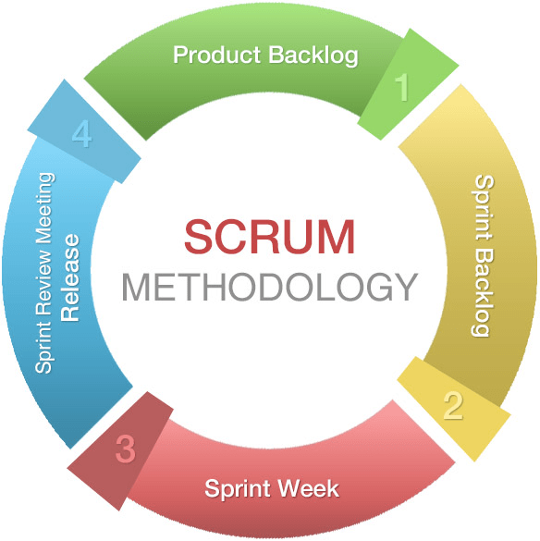
Figure 3.1: Agile Scrum Methodology (Mugorozi, 2020)

A research methodology acts as a clear roadmap to guide the development of a software project. For the TutorMeQuran web application, the developers will use the Agile Scrum methodology. Agile Scrum is an adaptive software development framework that focuses on flexibility and continuous improvement (Muay et al., 2024). Instead of trying to build the whole system at once, this method divides the workload into short, manageable work cycles known as Sprints (Nurhaeni et al., 2024).

The Agile Scrum process starts by gathering all the required system features, such as the real-time booking calendar and the tutor verification upload, into a main master list called the Product Backlog. During the development phase, the developer will select a few high-priority tasks from this list and complete them within a specific Sprint. Each Sprint acts like a mini-project that includes the process of planning, designing, coding, and testing.

By using this step-by-step approach, the developer can focus on building one specific module at a time. This method is very helpful because core functions can be tested early to ensure there are no double-booking errors before moving to the next feature. Overall, this chapter will explain the detailed phases of Agile Scrum and the specific hardware and software requirements needed to complete the TutorMeQuran project successfully.

3.1.1 Justification for Agile Scrum

There are two main types of software development approaches, which are predictive and adaptive. The Waterfall method is a predictive approach where everything must be planned strictly from the start. However, this project chooses Agile Scrum because it is an adaptive approach.

The main reason for choosing Agile Scrum is its high flexibility. It allows us to make changes to the system requirements even during the middle or late stages of development. According to Muay et al. (2024), Agile Scrum is highly suitable for web applications because it can adapt to changes easily. For the TutorMeQuran project, this flexibility is very useful. If the supervisor or target users request adjustments to the booking flow or any kind of feature during testing, the developer can simply update the system without having to restart the whole project. To make this development process easier to understand, all the specific activities and deliverable are summarize in the next section.

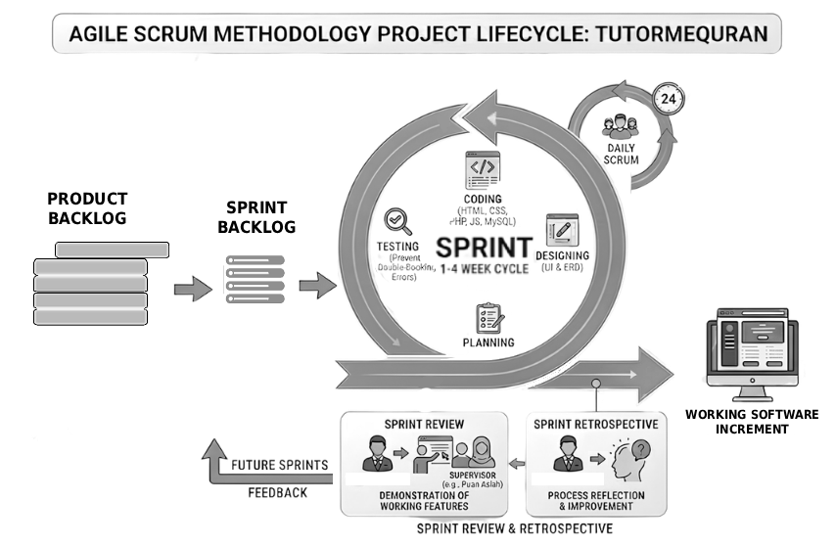
Figure 3.2: Agile Scrum Project Lifecycle for TutorMeQuran

3.1.2 Overview of Agile Scrum Phases

Phase (Agile Scrum) | Activities | Deliverables | Objectives
Phase 1: Product Backlog | • Identify problem areas regarding manual Quran booking issues.  • Gather specific system requirements for Admin, Tutor, and Student roles.  • List and prioritize all required features. | - Problem Statement  - Research Objectives  - Product Backlog | To identify, analyze, and prioritize the exact functional requirements needed for the web application. (RO1)
Phase 2: Sprint Backlog | • Select high-priority features from the Product Backlog to build first  • Break down the selected features into smaller development tasks.  • Visualize the requirements for this specific cycle. | - Sprint Backlog  - Use Case Diagram  - Software Requirement Specification (SRS) | To plan and allocate specific, manageable tasks for the upcoming development cycle. (RO1)
Phase 3: Sprint Week Execution (Iterative Design & Development) | • Design the user interface (UI) and database architecture (MySQL) for the current sprint's tasks.  • Write the HTML, CSS, JavaScript, and PHP code.  • Build the scheduling algorithms and payment verification through DuitNow receipt upload | - Entity-Relationship Diagram (ERD)  - Software Design Document (SDD)  - Working Software Increment | To develop the complete web-based booking application according to the approved designs. (RO2)
Phase 4: Sprint Review, Retrospective and System Evaluation | • Test the newly built features to ensure there are no double-booking errors.  • Evaluate the interface using the System Usability Scale (SUS) questionnaire.  • Review user feedback and update the Product Backlog for the next sprint. | - SUS Evaluation Report  - A fully functional TutorMeQuran web application | To evaluate the developed features for system effectiveness and usability before moving to the next cycle. (RO3)
Table 3.1 Overview Table of Agile Scrum Phases

3.2 Phase 1: Product Backlog

The first phase in the Agile Scrum methodology is the Product Backlog. The main purpose of this phase is to achieve Research Objective 1 (RO1), which is to identify the system requirement for the web application. In this stage, the developer focus on understanding the current situation of Quran tutor booking in Malaysia. The main activity is to identify the problems that happen when people use manual booking methods like WhatsApp or phone calls, which often lead to miscommunication and scheduling conflict (Saavedra et al., 2024). To avoid confusing and overlapping issues, the developer decided to narrow down the scope and only take the three most critical problems to create a clear problem statement. This step is very important to make sure the project have a strong research objective.

After the problem is identified, the next step is to gather the specific system requirements, set the project boundary, and understand the target user. Therefore, the developer conduct a requirement analysis, set the system scope, and define the user roles clearly below.

3.2.1 Initial Requirement Gathering

To gather the system requirements for TutorMeQuran two techniques were used: Literature Review Analysis and User Survey.

3.2.1.1 Literature Review Analysis
For the first technique, the developer conduct a literature review analysis. This step involve reading past research paper and article related to Quranic education and web booking system. By reading previous study, the developer can clearly understand the main problem that student and tutor face when using manual booking method like WhatsApp, which is proven to be inefficient and prone to double-booking errors (Natarajan et al., 2024). From this analysis, the developer can also identify the need for a proper tutor verification system to ensure education quality (Al-khatib, 2023). Therefore, the developer can identify the specific functional and non-functional requirement needed to build a much better web application.

3.2.1.2 User Survey
The second technique used to gather requirement is a user survey. The developer create an online questionnaire using Google Form and distribute it to 30 target users. The target user include university student, parent, and independent Quran tutor in Malaysia. This survey aim to collect real data about their current experience and what kind of feature they actually want in a new booking system. This preliminary requirement gathering is completely different from the System Usability Scale (SUS) survey method. The SUS evaluation method will only be used later in Phase 4 to specifically measure the system usability with 15 target participants.

3.2.2 System Scope

The system scope define what is include and exclude in this project.

- Include Scope: The system cover user registration, personal profile management, Ijazah verification upload, real-time booking with scheduling, and integration of payment processing
- Exclude Scope: The system does not have a built-in video call function. For online class type, the tutor and student will use external platform like Google Meet or WhatsApp Video.

3.2.3 User Roles

For the TutorMeQuran web application, there are three main user roles involve in the system. Each role have different access and function:

- Admin: The admin is responsible to manage the overall system, view user data, and approve the tutor registration.

- Tutor: The tutor can manage their personal profile, upload Ijazah certificate for verification, and manage class booking from students.

- Student: The student can search for a suitable tutor, view the real-time calendar, and make a class booking easily.

Based on the user roles and system scope above, all of the required features are then listed and prioritized into a master list. This master list is known as the Product Backlog. According to Muay et al. (2024), the Product Backlog act as the main requirement list that guide the development of the system.

3.3 Phase 2: Sprint Backlog

The next step in the Agile Scrum framework is Phase 2, which is the Sprint Backlog. This phase is conduct to support and complete Research Objective 1 (RO1) by planning the specific task and system design clearly. In this phase, the developer need to select high-priority features from the main Product Backlog. Because it is impossible to build everything at one time, the developer chooses the most important functions to build first. These important feature include the tutor search function, the real-time booking calendar, and the Ijazah upload verification.

After selecting the features, the developer break down the large features into smaller development tasks. This smaller task list is call the Sprint Backlog. To make sure the system logic is correct before coding, the developer also visualize the system requirements. This is done by drawing a Use Case Diagram and a Flow Overview to show how the Student, Tutor, and Admin interact with the web application.

According to Nurhaeni et al. (2024), proper sprint backlog planning is very important to make sure the developer focus on specific module for the upcoming cycle.

3.3.1 Use Case Diagram for TutorMeQuran

A use case diagram is a visual representation that show how different users interact with the system. For the TutorMeQuran web application, this diagram identify the three main actors which are Student, Tutor, and Admin. It help to map out the specific action they can do such as make booking, upload certificate, and manage user account. By drawing this diagram, the developer can clearly understand the system flow and permission for each role before the coding process begin.
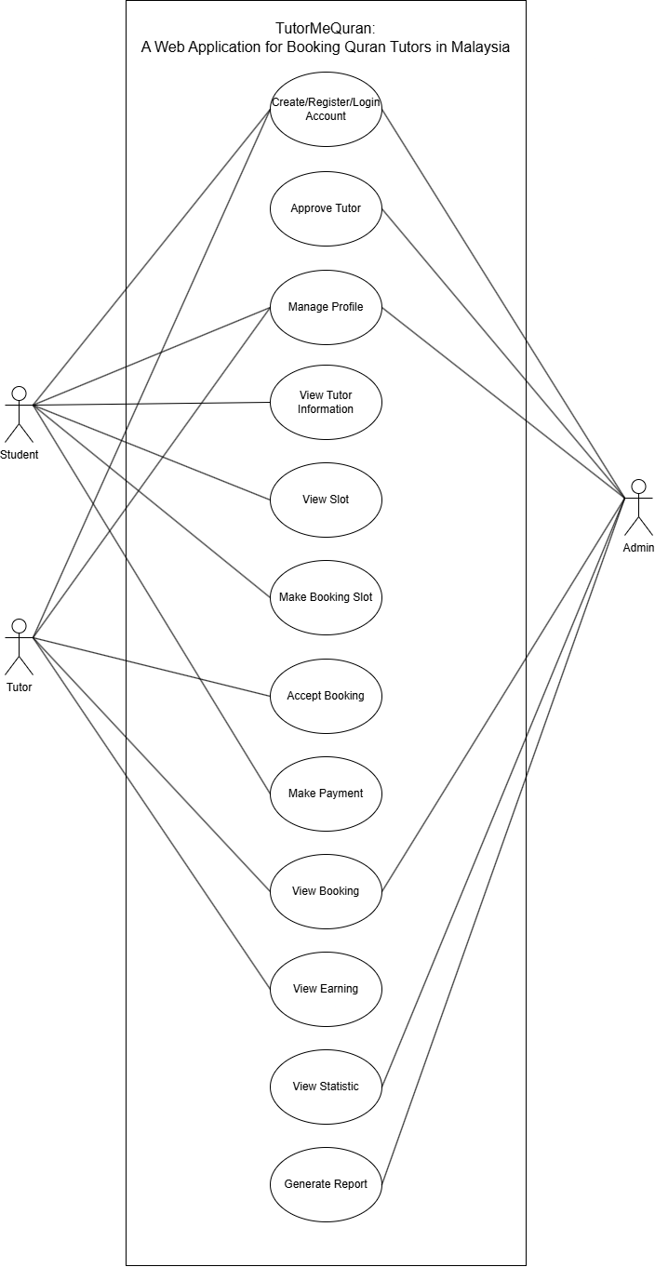
Figure 3.3: Use Case Diagram for TutorMeQuran

3.3.2 Flow Overview of the System
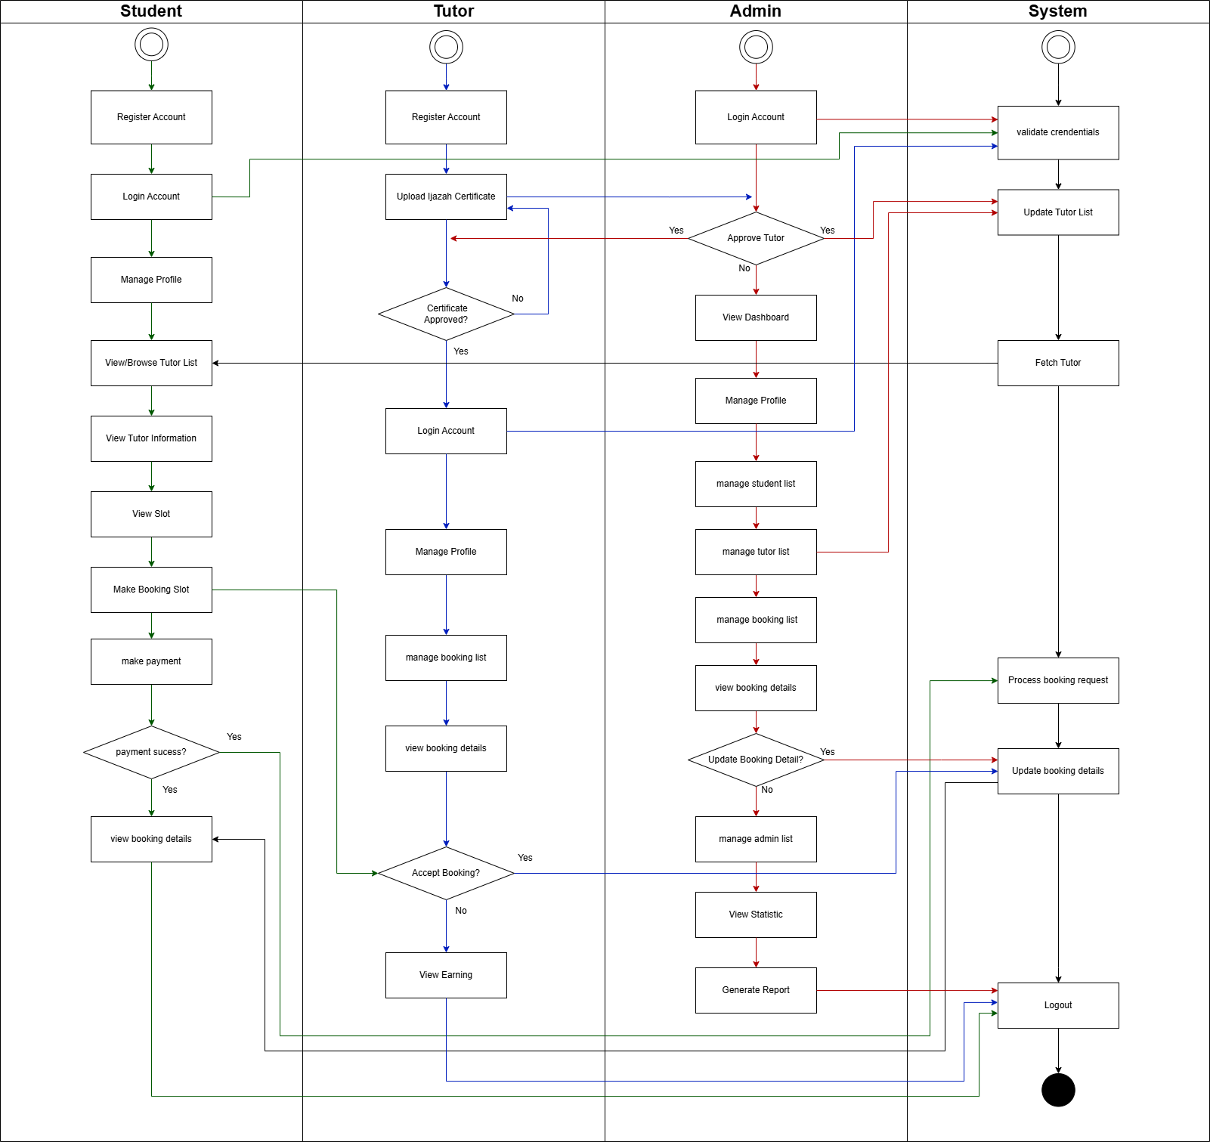
Figure 3.4: Flowchart Overview of the system for TutorMeQuran

3.3.3 System Requirement Specification (SRS)

After the visual diagram is done, the developer conduct a detailed requirement analysis. This step will list down the specific system requirement to be included in the Software Requirement Specification (SRS) document. This analysis is divide into functional requirement, non-functional requirement, hardware, and software requirement.

3.3.3.1 Functional Requirements
ID | Description
FR1 | The system should allow Student and Tutor to create account
FR2 | The system should allow Student and Tutor to log in account
FR3 | The system should allow all user to edit their account profile
FR4 | The system should allow Student to search for tutor
FR5 | The system should allow Student to book tutor based on available time slot.
FR6 | The system should allow Student and Tutor to edit or cancel booking.
FR7 | The system should allow Student and Tutor to view past booking and upcoming booking
FR8 | The system should allow Tutor to upload ijazah certificate for verification
FR9 | The system should allow Tutor to view booking list
FR10 | The system should allow Admin to approve/disapprove uploaded Tutor’s ijazah certificate
FR11 | The system should allow Tutor to add and update their teaching availability.
FR12 | The system should allow Student to upload DuitNow payment receipt after booking.
FR13 | The system should allow Admin to verify DuitNow payment receipt.
FR14 | The system should allow Admin to generate comparison and composition report
FR15 | The system should provide a simple rule-based FAQ chatbot to answer common questions about booking, payment, tutor verification, and system usage.
Table 3.2 Functional Requirement and Description

3.3.3.2 Non-Functional Requirements
ID | Description
NFR1 | Usability: The web application must be easy to use and navigate for all user.
NFR2 | Security: The system must protect user password and keep personal data secure.
NFR3 | Reliability: The system should function smoothly without crashing during the booking and payment process.
NFR4 | Performance: The system should process user login within 3 seconds under normal internet connection.
NFR5 | Performance: The system should display tutor search result within 5 seconds after the student submit the search request.
NFR6 | Scalability: The system should support at least 50 concurrent users accessing the website at the same time during normal usage.
NFR7 | Availability: The system should be accessible through a web browser when the server and internet connection are available.
NFR8 | Compatibility: The system interface should be readable on laptop and smartphone screen.
NFR9 | Data Integrity: The system should prevent duplicate booking by checking tutor availability before confirming a booking.
Table 3.3 Non-Functional Requirement and Description

3.3.3.3 Hardware
The hardware requirement explain the physical device needed to develop the system. Table 3.4 show the hardware specification used by the developer to make sure the coding process and local server can run smoothly.
Hardware | Specification
Operating System | Windows 10 or 11 (64-bit)
Memory (RAM) | 8GB RAM
Storage | 512GB Solid State Drive (SSD)
Device Type | Standard Development Laptop
Table 3.4 Hardware Requirements

3.3.3.4 Software
Software | Name
Code Editor | Visual Code Studio
Programming Languages | HTML, CSS, JavaScript, PHP
Database Management | MySQL (via XAMPP)
Version Control | Git & GitHub
Table 3.5 Software Requirements

3.4 Phase 3: Sprint Week Execution (Iterative Design & Development)

In Phase 3, which is the Sprint Execution, the developer start the actual development work. The main objective of this phase is to achieve Research Objective 2 (RO2), which is to design and develop the TutorMeQuran web application. During this iterative design and development stage, the developer translate the planned requirement into a working web application. The first main activity is to sketch the low-fidelity user interface (UI) wireframe to plan the system layout. After the visual interface is planned, the next step is building the database architecture using MySQL. To show how the database table are connected to each other, the developer create an Entity-Relationship Diagram (ERD) before writing the actual code.

3.4.1 User Interface Wireframe

A user interface (UI) wireframe is a simple visual guide that show the basic structure of a web page. In this step, the developer draw a low-fidelity wireframe to plan how the system will look like before writing the HTML and CSS code. By drawing this wireframe early, it help the developer to make sure the system flow is easy to navigate and achieve a good usability standard.
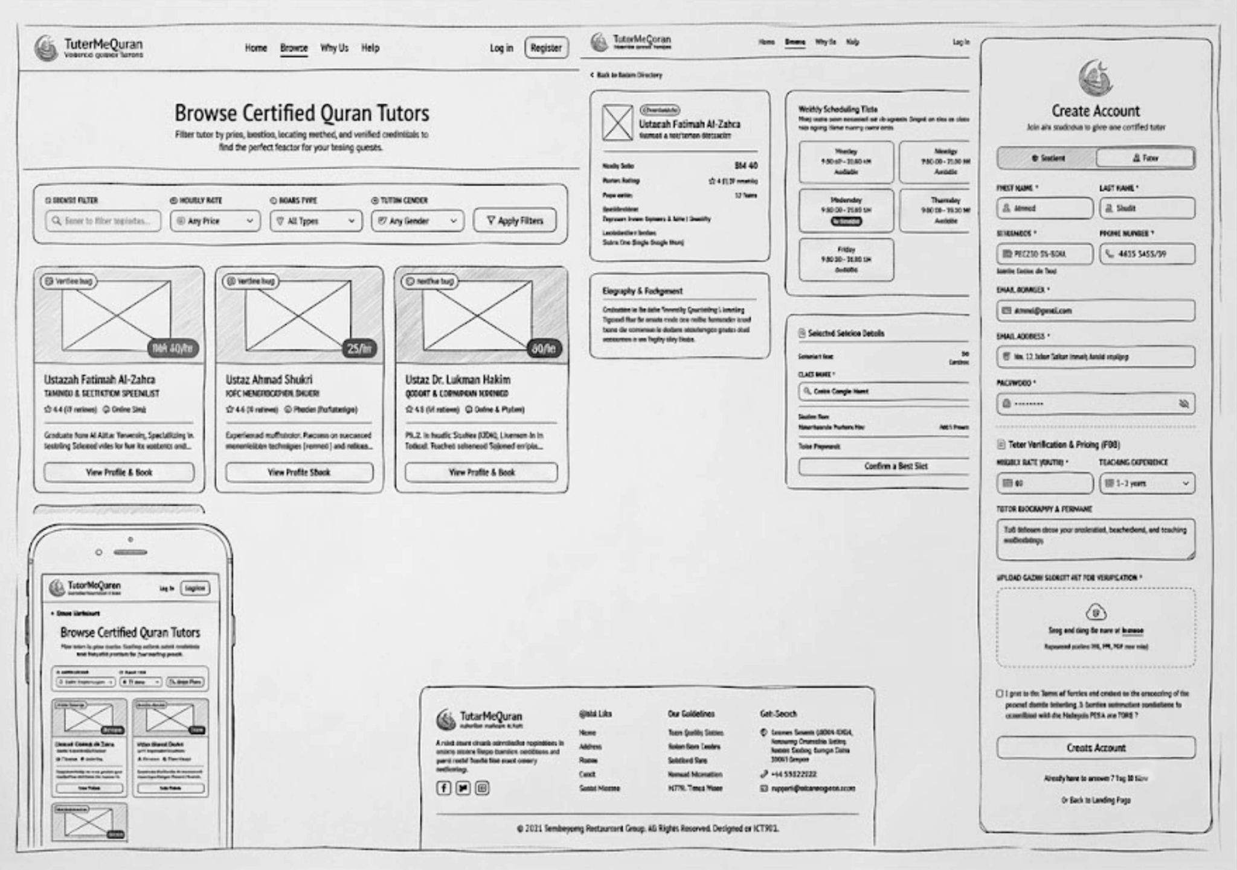
Figure 3.5: Low-fidelity User Interface (UI) Wireframe of TutorMeQuran

3.4.2 Entity-Relationship Diagram for TutorMeQuran

An entity-relationship diagram (ERD) is a structural model that illustrate how data is stored and connected inside the system database. For this project, the developer use ERD to plan the MySQL database table like Student, Tutor, Booking, and Certificates. It show the primary key and foreign key relationship to make sure there is no data duplication. This diagram is very important to build a strong and secure backend database for the TutorMeQuran application.
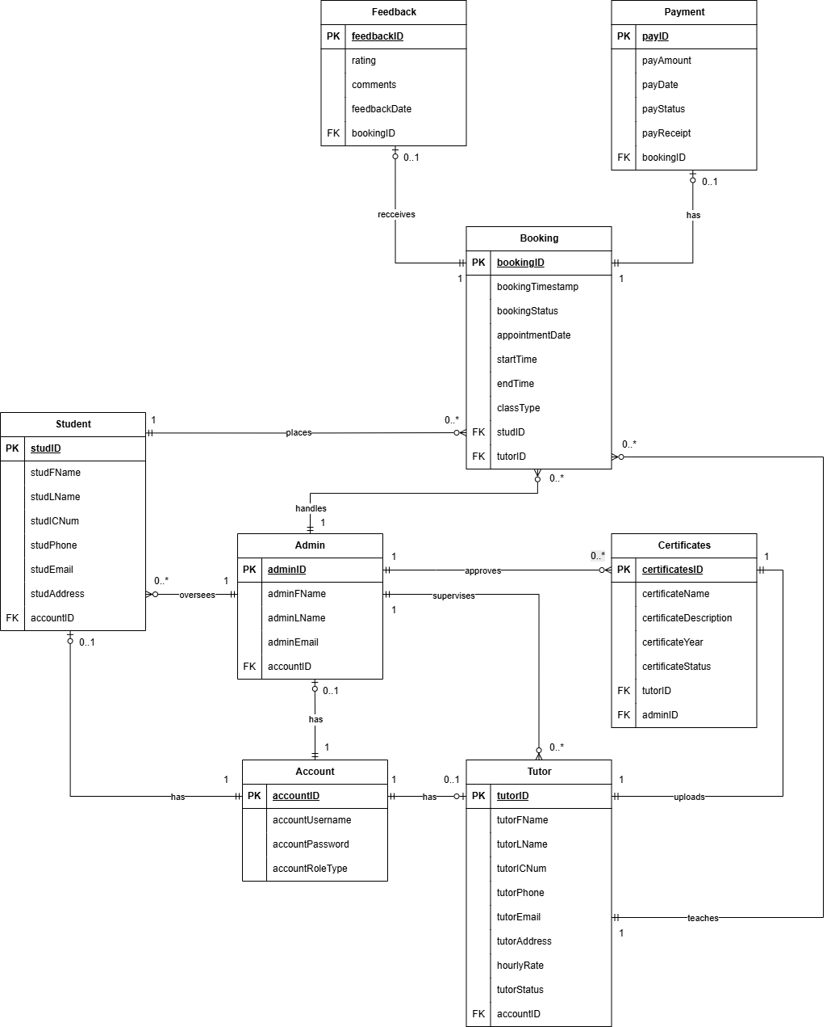
Figure 3.6: Entity Relation Diagram (ERD) for TutorMeQuran

Relationship | Cardinality | Description & Business Rule
Account to Student/Tutor/Admin | 1:0..1 | A single login account can have one profile (Student, Tutor, or Admin). Role-based access is enforced here.
Admin to Student / Tutor / Booking | 1:0..M | Admin can performs CRUD on any of these entities. Therefore, admin supervises many tutor (or none if no tutor registered), admin handles many booking (or none if no booking created), lastly admin oversees many student (or none if no student registered)
Admin to Certificates | 1:0..M | Admin approves certificates. A certificate can only be approved by one admin, but one admin approves many.
Student to Tutor (via Booking) | M:M | Booking is the bridge (associative entity) that resolves the many-to-many between Students and Tutors. A student has many bookings; a tutor has many bookings.
Tutor to Certificates | 1:1 | A tutor can only upload one certificate ijazah
Booking to Payment | 1:0..1 | A booking may have one payment (or none if unpaid). Payment is optional until confirmed.
Booking to Feedback | 1:0..1 | A booking may have one feedback (or none if not yet given).
Table 3.6 Entity Relationship Diagram (ERD) Description

After the design part is done, the developer continue with writing the actual code. The system is develop using HTML, CSS, JavaScript, and PHP programming language. This coding process is done iteration by iteration based on the task inside the Sprint Backlog.

By doing this method, the developer can make sure each module function properly before moving to another part. At the end of this Phase 3, the deliverables produced include the Entity-Relationship Diagram (ERD), the Software Design Document (SDD), and the Working Software Increment. The working software increment mean a completed small module that is ready to be evaluate in the next phase.

3.5 Phase 4: Sprint Review, Retrospective and System Evaluation

The final phase in the Agile Scrum methodology is Phase 4, which is the Sprint Review and Retrospective. The goal of this phase is to achieve Research Objective 3 (RO3), which is to evaluate the usability of the TutorMeQuran web application. In this stage, the developer conducts a testing and evaluation process to make sure the system work exactly as expected. One of the main activity is to test the newly built features. For example, the developer need to test the booking module to ensure there is no double-booking errors that happen when students book a class.

After the system functioning without error, the developer evaluate the user interface using the System Usability Scale (SUS) questionnaire. This questionnaire is given to the target user to measure how easy they can use the web application. From the result, the developer will review user feedback and update the Product Backlog for the next sprint.

Finally, the main deliverable produced at the end of this phase is the SUS Evaluation Report and a fully functional TutorMeQuran web application.

3.5.1 System Usability Scale (SUS) Questionnaire

To measure user satisfaction, the developer distribute a SUS questionnaire. The System Usability Scale (SUS) is a "quick and dirty" evaluation tool that provide a very reliable usability score (Brooke, 1996). After the system functioning without error, the target user need to test the system and rate it from 1 (Strongly Disagree) to 5 (Strongly Agree).

As for the testing sample size, Nielsen (2000) state that testing a system with only 5 users is already enough to find most of the usability problem. However, to get a more accurate and stable result specifically for a questionnaire, Tullis and Stetson (2004) suggest that a sample size of 12 to 14 participants is the most optimal. Therefore, the SUS evaluation will involve 15 participants consisting of students and Quran tutors who represent the target users of the system.

3.6 GANTT CHART

A Gantt chart is used to plan the project schedule and make sure the development process finish on time. Figure 3.6 show the Gantt chart timeline for TutorMeQuran web application. The project schedule start from week 1 until week 15 during Semester 5. By using this chart, the developer can track the progress of each Agile Scrum phase easily and avoid delay.

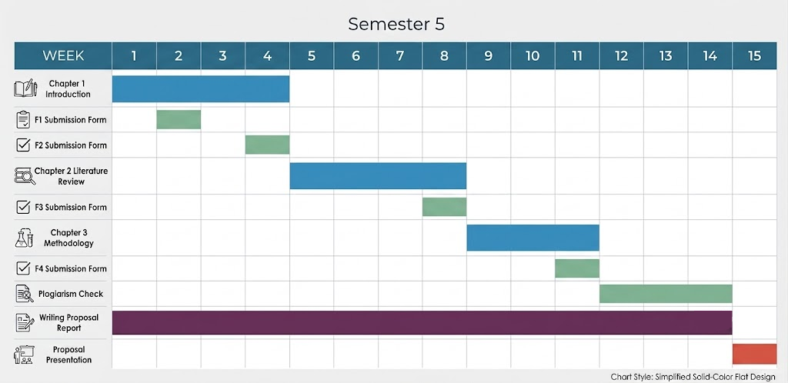
Figure 3.7 Gantt Chart For CSP600

3.7 CHAPTER SUMMARY

In summary, this chapter explains the methodology used to develop the TutorMeQuran web application. The developer choose the Agile Scrum methodology because it have high flexibility and can adapt to changes easily. This methodology is divide into four main phases which is Product Backlog, Sprint Backlog, Sprint Execution, and Sprint Review and Retrospective.

In Phase 1, the developer focus on finding the main problem and list all the required features into a Product Backlog. Then, Phase 2 involve planning the specific task into a Sprint Backlog and draw the Use Case Diagram. After that, Phase 3 is where the actual coding and database design happen using MySQL and PHP. Finally, Phase 4 is conduct to test the system for any double-booking error and evaluate user satisfaction using the SUS questionnaire.

Overall, this Agile Scrum framework help the developer to build the system step by step. It make sure the web application can be completed on time and solve the manual booking problem for Quran tutors in Malaysia.

REFERENCES
Abdullah, N. M. S. N., Rahim, F. N. B. A., & Omar, R. B. M. I. (2021). Exploring the challenges of sustaining Qur’anic memorization: A case study. Journal of Islamic Educational Research. https://ejournal.um.edu.my/index.php/JIER/article/view/28706

Al-khatib, I. A. (2023). The importance degree of the Quranic ijâzah at developing the skills of reciting and tajweed of the Holy Quran among Holy Quran teachers at the primary stage. Journal of Educational Science, 10(2), 18–46. https://www.researchgate.net/publication/400027315

Che Noh, M. A., Mat Ludin, M. S., & Suhid, A. (2013). Teaching competency among Islamic educators in Malaysia. World Applied Sciences Journal, 24(2), 13–20. https://www.idosi.org/wasj/wasj24(2)13/20.pdf

Faris, A. F., Rahman, S. N. H. A., Jima'ain, M. T., Faisal, M. S., & Mustafa, R. R. (2023). Quranic reading proficiency and factors affecting mastery Quran among public university students. Bitara International Journal of Civilizational Studies and Human Sciences. https://www.bitarajournal.com/bitarajournal/article/download/415/442

Hajdari, A. (2023). Designing a relational database schema for a Kosovo hospital management system. In The software principles of design for data modeling (pp. 194–210). IGI Global. https://www.igi-global.com/gateway/chapter/330497

Hassan, A., Pavel, M. I., Muhtasim, D. A., Kamal, S. M., Shahi, H., & Rumpa, F. I. (2021). Enhanced security of user authentication on doctor e-appointment system. ResearchGate. https://www.researchgate.net/publication/352879634_Enhanced_Security_of_User_Authentication_on_Doctor_E-Appointment_System

Ismail, F. B. H., Sabirin, S., Zahari, W. A. M. B. W., Rouzi, K. S., & Kirin, A. B. (2022). The practice of reading al-Qur'an among Islam youths. QiST: Journal of Quran and Tafseer Studies. https://journals2.ums.ac.id/qist/article/view/1062

Ismail, M. J., Baharudin, H., Razak, K. A., & Abdul Hamid, M. F. (2025). The impact and challenges of mentoring implementation in hifz al-Quran teaching at tahfiz institutions in Malaysia: A preliminary review. International Journal of Research and Innovation in Social Science. https://rsisinternational.org/journals/ijriss/Digital-Library/volume-9-issue-1/2700-2707.pdf

Mohd Ghazali, J., Mohd Danuri, M. S. N., Ahmad, S. N., Ismail, A. Z., Ngah, M. I., & Yanuarsyah, I. (2025). Challenges and educators’ perceptions of integrity in online Quran memorization (tasmik) assessments. Malaysian Journal of Information and Communication Technology. https://myjict.uis.edu.my/index.php/journal/article/view/233

Mohtar, S., Jomhari, N., Yusoff, M. Z. M., & Mustafa, M. B. (2022). Factors and challenges in understanding al-Quran using technology during pandemic Covid-19. Quranica: International Journal of Quranic Research. https://ejournal.um.edu.my/index.php/quranica/article/view/41081

Muay, N. T., Sediyono, E., & Tambotoh, J. (2024). Integration Waterfall and Scrum methodology in the development of SIMARGA web application. Jurnal RESTI, 8(2), 223–233. https://jurnal.iaii.or.id/index.php/RESTI/article/view/5652

Natarajan, S., Harirajkumar, J., Santhosh, S., & Srinith, R. (2024). Online hospital appointment booking. In Proceedings of 9th International Conference on Science, Technology, Engineering and Mathematics: The Role of Emerging Technologies in Digital Transformation, ICONSTEM 2024. Institute of Electrical and Electronics Engineers Inc. https://ieeexplore.ieee.org/document/10568655

Nurhaeni, T., Septiani, N., Wandi, M., Zainum Ikhsan, R., Maulana, S., & Mertayasa, I. K. (2024). Optimizing e-commerce performance through Agile Scrum methodology and Yii framework integration using a data-driven approach. In 2024 3rd International Conference on Creative Communication and Innovative Technology, ICCIT 2024. Institute of Electrical and Electronics Engineers Inc. https://ieeexplore.ieee.org/document/10701261

Othman, N. F. B., & Yusof, M. F. M. (2023). Perusing learning challenges in the digital era: Between Qur’ānic concepts and contemporary education. Journal of Quran Sunnah Education and Special Needs. https://jqss.usim.edu.my/index.php/jqss/article/view/199

Pasaleron, R., Afrianto, A., Junaidi, A., Rahman, I., & Susanti, W. (2023). Problems of teachers and students in learning the Quran. Al-Fikrah: Jurnal Studi Ilmu Pendidikan dan Keislaman. https://ojs.stai-bls.ac.id/index.php/ajie/article/view/62

Piçirgen, A., & Peker, S. (2021). A UML-based conceptual model for appointment booking systems. In Proceedings 6th International Conference on Computer Science and Engineering UBMK 2021 (pp. 812–817). https://ieeexplore.ieee.org/document/9558929

Ramli, M. S., Sahad, M. N., & Mohd Din, K. F. (2026). Issues, teaching methods, and learning support for early childhood Qur'an reading: A systematic review. Jurnal Pendidikan Awal Kanak-kanak Kebangsaan . https://ejournal.upsi.edu.my/index.php/JPAK/article/view/12756

Saavedra, C., Honores, C., & Ticona, W. (2024). Implementation of a web-based system to improve the appointment process in a clinic. In Proceedings of the 14th International Conference on Cloud Computing Data Science and Engineering Confluence 2024 (pp. 116–123). https://ieeexplore.ieee.org/document/10463205

Safari, M. S., Abdullah, M. B., & Ahmad Dahlan, A. R. (2018). eTutor4U platform: Acquiring knowledge and skills with the help of great tutors. IEEE. https://ieeexplore.ieee.org/document/8567123

Sahmat, M. S., & Zamri, F. A. (2024). Enhancing Al-Quran reading proficiency in higher education: The implementation of the Focused Mad & Idgham technique. Journal of Cognitive Sciences and Human Development. https://publisher.unimas.my/ojs/index.php/JCSHD/article/view/6599

Salleh, N. M., Ismail, S., Yusoff, H., Hussin, H., & Hafiz, M. (2025). Technology integration in Quranic learning: An analysis of effectiveness. e-Jurnal Penyelidikan dan Inovasi. https://ejpi.uis.edu.my/index.php/ejpi/article/view/270

Samarh, S. N. A., Mustafa, M. A., Daud, Z. B., & Yusoff, M. F. B. M. (2025). Navigating the labyrinth: Malaysian students’ struggles and insights in mastering variant readings of the Quran. Quranica: International Journal of Quranic Research. https://ejournal.um.edu.my/index.php/quranica/article/view/62582

Senadeera, K., & Nawinna, D. (2024). Usability evaluation of e-learning website. In 2024 6th International Conference on Advancements in Computing, ICAC 2024 (pp. 31–36). Institute of Electrical and Electronics Engineers Inc . https://ieeexplore.ieee.org/document/10851087

Thamilarasan, Y., Raja Ikram, R. R., Osman, M., Salahuddin, L., Wan Bujeri, W. Y., & Kanchymalay, K. (2023). Enhanced System Usability Scale using the software quality standard approach. Engineering, Technology and Applied Science Research, 13(5), 11779–11784. https://www.etasr.com/index.php/ETASR/article/view/5971

Vlachogianni, P., & Tselios, N. (2022). Perceived usability evaluation of educational technology using the System Usability Scale (SUS): A systematic review. Journal of Research on Technology in Education, 54(3), 392–409. https://www.tandfonline.com/doi/full/10.1080/15391523.2020.1867938

TeacherOn. (n.d.). TeacherOn: Online and local tutors. Retrieved May 17, 2026, from https://www.teacheron.com/

Qutor. (n.d.). Qutor: Learn Quran online. Retrieved May 18, 2026, from https://qutor.com/

Preply. (n.d.). Preply: Learn with online tutors. Retrieved May 18, 2026, from https://preply.com/

Superprof. (n.d.). Superprof Malaysia: Find the perfect private tutor. Retrieved May 20, 2026, from https://www.superprof.com.my/

MyTutor. (n.d.). MyTutor: Malaysia's online tuition platform. Retrieved May 21, 2026, from https://mytutor.my/

Mugorozi, F. (2020, February 20). My understanding of the Scrum Framework and benefits of the Scrum events. Medium. https://medium.com/@francoismugorozi/my-understanding-of-the-scrum-framework-and-benefits-of-the-scrum-events-ebd889da1472

Brooke, J. (1996). SUS: A "Quick and Dirty" Usability Scale. In P. W. Jordan, B. Thomas, B. A. Weerdmeester, & I. L. McClelland (Eds.), Usability Evaluation In Industry. Taylor & Francis. https://www.taylorfrancis.com/chapters/edit/10.1201/9781498710411-35/sus-quick-dirty-usability-scale-john-brooke

Nielsen, J. (2000, March 18). Why you only need to test with 5 users. Nielsen Norman Group. https://www.nngroup.com/articles/why-you-only-need-to-test-with-5-users/

Tullis, T. S., & Stetson, J. N. (2004). A comparison of questionnaires for assessing website usability. Usability Professional Association Conference, 1-12. https://www.researchgate.net/publication/228609327_A_Comparison_of_Questionnaires_for_Assessing_Website_Usability
APPENDIX

